SNC2P June 2017
ANSWERS - Culminating Task: Review for Final Exam (10% of final mark)

Unit 1: Chemistry – Elements and Compounds
- Bohr-Rutherford Diagrams:

- In the centre of the atom is the nucleus which contains two types of particles: protons which have a postive charge and neutrons which have no charge.

- The electrons which have a negative charge are found in the orbits around the nucleus.

- The number of protons always equals the number of electrons in an atom.

- When the number of electrons is not the same as the number of protons, it is no longer called an atom; it is called an ion.

- Metals can become positive ions by losing electrons and non-metals can become negative ions by gaining electrons.

Word List: electrons gaining ion losing negative protons positive

- Complete the following chart:
Element | Bohr-Rutherford diagram of the atom | Bohr-Rutherford diagram of the ion that it forms | Symbol and charge of the ion
Sodium |  |  | Na⁺
chlorine |  |  | Cl⁻
Calcium |  |  | Ca²⁺
Nitrogen |  |  | N³⁻

- Types of Compounds

- Simple binary ionic compounds are formed between a metal and a non-metal.

- Polyatomic compounds are formed between a metal and a polyatomic ion.

- ________________ is an example of a polyatomic ion.

- Acid contain hydrogen and are dissolved in water.

- Molecular compounds are formed between 2 non-metals.

- Only molecular compounds form a unit called a molecule.

Word List: hydrogen metal molecule non-metal

The Compound Consists of: | Type of compound that will form | Name of Compound | Formula of Compound
Calcium and fluorine | ionic | Calcium fluoride | CaF₂
potassium and nitrate | Ionic | Potassium nitrate | KNO₃
Hydrogen and sulfate | acid | Sulfuric acid | H₂SO_{4(aq)}
Carbon and oxygen | Molecular | Carbon dioxide | CO₂

- Naming and Writing Formulas for Compounds

- The name of simple binary ionic compounds end with “ide”.

- If there is more than one of a polyatomic ion in a formula, the polyatomic ion is placed in brackets.

- All acids contain hydrogen and have (aq) written after the formula.

- The names of all acids end with “ic” acid.

- Oxyacids also contain oxygen and do not begin with the prefix “hydro”.

- The name of molecular compounds use the prefixes mono, di, tri, tetra, penta, to show how many atoms of each element are in the formula.

Word List: brackets di hydro hydrogen ic ide penta tetra tri

Complete the following chart:

Formula of Compound | Type of Compound | Name of Compound
NaBr | Ionic | Sodium bromide
Al₂S₃ | Ionic | Aluminum sulfide
MgO | Ionic | Magnesium oxide
CaCl₂ | Ionic | Calcium chloride
KHCO₃ | Ionic | Potassium hydrogen carbonate
MgSO₄ | Ionic | Magnesium sulfate
NaOH | Ionic | Sodium hydroxide
H₂CO_{3(aq)} | Acid | Carbonic acid
HCl_{(aq)} | Acid | Hydrochloric acid
CF₄ | Molecular | Carbon tetrfluoride
H₂O | Molecular | Dihydrogen monoxide or water
N₂O₄ | molecular | Dinitrogen tetraoxide
Li₂S | Ionic | Lithium sulfide
Ca(NO₃)₂ | Ionic | Calcium nitrate
NO₃ | Molecular | Nitrogen trioxide
H₃PO_{4(aq)} | Acid | Phosphoric acid
CO | Molecular | Carbon monoxide
Mg(NO₃)₂ | Ionic | Magnesium nitrate
HF_{(aq)} | Acid | Hydrofluoric acid
AgOH | Ionic | Silver hydroxide
ZnO | Ionic | Zinc oxide
CuBr₂ | Ionic | Copper bromide
Cl₂O₅ | molecular | Dichlorine pentaoxide

Unit 2: Chemistry – Chemical Reactions

- The Law of Conservation of Mass states that:
The total mass of the reactants = the total mass of producta

- Identify the term described below:
- A type of reaction that involves the combining of 2 elements synthesis

- The breaking apart of a compound into its elements decomposition

- The number placed in front of a formula in a balanced equation coeffiecient
Word List: coefficient decomposition products synthesis

- Write the WORD EQUATION for each of the following:

- A piece of zinc metal added to silver nitrate produces zinc nitrate and silver
Zinc + silver nitrate zinc nitrate + silver

- When zinc carbonate is heated, zinc oxide and carbon dioxide are produced
Zinc carbonate zinc oxide + Carbon dioxide

- Nitrogen and oxygen gases react in automobile engines to produce nitrogen dioxide
Nitrogen + oxygen nitrogen dioxide

- Hydrogen and nitrogen gas react to make ammonia

Hydrogen + nitrogen ammonia

- From question #3, which reactions are:
- Synthesis c and d
- Decomposition b
- Single displacement a
- Double displacement none

- Balance the following equations:

- 2CO + O₂ 2CO₂

- Cl₂ + 2KBr Br₂ + 2KCl

- 4NH₃ + 3O₂ 2N₂ + 6H₂O

- Complete the missing products with proper chemical formulas, balance the equations and state the type of reaction.
a. | Ca + 2HBr CaBr₂ + H₂ | Single displacement
b. | 4Al + 3O₂ 2Al₂O₃ | synthesis
c. | KNO₃ + HBr KBr + HNO₃ | Double displacement
d. | 3CaCl₂ + Al₂(SO₄)₃ 3CaSO₄ + 2AlCl₃ | Double displacement
e. | C₃H₈ + 5O₂ 3CO₂ + 4H₂O | combustion
f. | BaCl₂ + Na₂SO₄ 2NaCl + BaSO₄ | Double displacement
g. | 2 KClO₃ 2 KCl + 3 O₂ | decomposition

Unit 3: Chemistry – Acids and Bases

- Classify each of the following as acid, base or neutral.

a) a solution with a pH of 3 acid

b) vinegar acid

d) a solution of sodium hydroxide base

e) has a sour taste acid

f) a solution with a pH of 8 base

g) pure water neutral

h) feels slippery and tastes bitter base

i) HNO_{3(aq)} acid

j) a cleaning solution that contains ammonia base

k) has a pH of 7.0 neutral

l) antacid tablets base

m) produces carbon dioxide gas when sodium
carbonate is added to it acid

n) a solution that contains equal amounts of sodium hydroxide
and hydrochloric acid neutral

- Complete the following descriptions with the most appropriate word(s).

a) a reaction between an acid and a base neutralization

b) a number that represents the degree of acidity pH

e) 2 products of neutralization salt and water

- The dye from plants that is a different colour
in an acid than in a base natural indicator

- This indicator can tell you the pH of a substance universal indicator

Word List: natural indicator neutralization pH salt universal indicator water
- Complete the following reactions that involve acids and bases.

  - zinc + hydrobromic acid zinc bromide + hydrogen

  - sulfuric acid + calcium carbonate calcium sulfate + water + carbon dioxide

  - hydrochloric acid + potassium hydroxide potassium chloride + water

- Identify the following substances as acid or base.

a) H₂SO_{4(aq)} acid b) NaOH base
c) calcium hydroxide base d) HCl_{(aq)} acid
Unit 4: Biology

- Cells and Cell Division
- Match the following descriptions with appropriate term by placing the letter of the term in the column on the right. A term may possibly be used more than once. Not all terms will be used.

 | Description | Term
1 | Controls cell activities | Nucleus
2 | Only plant cells have this cell structure | Cell wall
3 | The movement of a substance from an area of high concentration to an area of low concentration | Diffusion
4 | A part of a cell that performs a specific task | Organelle
5 | The cell spends most of its time in this phase of the cell cycle | Interphase
6 | A group cells working together for a specific function | tissue
7 | Allows certain things to enter the cell | Cell membrane
8 | The cell structure that contains the DNA | Nucleus
9 | Makes energy available to the cell | Mitochondria
10 | The cell grows during this phase of the cell cycle | Interphase
11 | This causes cells to move out of interphase sooner than usual | Cancer
12 | Each chromosome is made up of 2 identical copies of this material | DNA
13 | Chromosomes line up along the middle of the cell in this phase of the cell cycle | Metaphase
14 | The process of cell division | mitosis

Word List: cancer cell membrane cell wall diffusion DNA interphase metaphase mitochondria mitosis nucleus organelle tissue

- Label the parts of the cell indicated on the diagram.

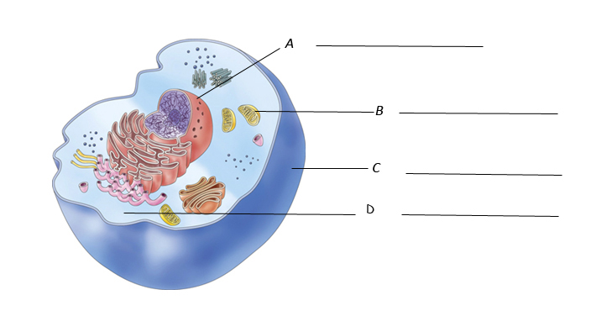
Word List: cell membrane (C) cytoplasm D mitochondria B nucleus A

Tissue, Organs and Organ Systems

- Complete the chart below.

 | Description | Term
1 | A cell that can differentiate into many different types of cells | Stem cells
2 | The stomach is a part of this system | Digestive
3 | A group of tissues working together to perform a complex body function | Organ
4 | A blood vessel that delivers blood to the heart | Vein
5 | This system delivers oxygen to the rest of the body | Circulatory
6 | Is an example of an organ | (Your choice)
7 | A blood vessel that delivers blood away from the heart | Artery
8 | The lungs are a part of this system | Respiratory

Word List: artery circulatory system digestive system organ respiratory system stem cell vein

- Label the parts of the digestive system indicated on the diagram below.

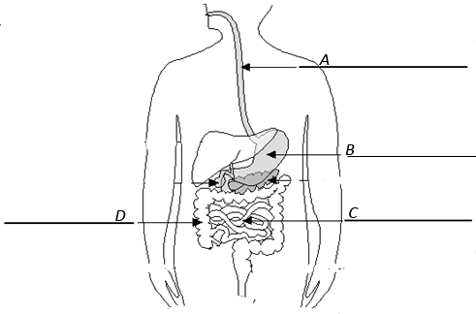

Word List: esophagus A large intestine D small intestine C stomach B

- Label the parts of the respiratory system indicated on the diagram below.

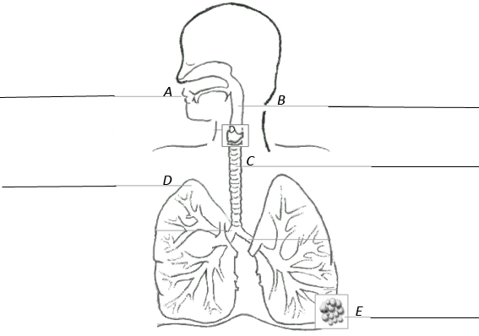

Word List: alveoli E larynx B lungs D mouth A trachea C

Unit 5: Light and Optics

- Complete the following chart.

 | Description | Term
1 | The part of the electromagnetic spectrum that we can see | Visible light
2 | Light travels as a ---- | Wave
3 | Light that is produced by heating an object to very high temperatures | Incandescence
4 | Light that is produced by first absorbing UV light | Phosphorescence or fluorescence
5 | Light bulbs that don’t require a filament | LEDs
6 | Glow in the dark toys are an example of this type of light production | Phosphorescence
7 | Objects that let light travel straight through them | Transparent
8 | The process in which light bounces of an object | Reflection
9 | The ray of light heading toward an object | Incident ray
10 | A caved in mirror | Concave
11 | A curved mirror like the back of a spoon | Convex
12 | Images appear this way in convex and in plane mirrors | Upright
13 | The bending of light | Refraction

Word List: concave convex fluorescence incandescence incident ray LEDs phosphorescence reflection refraction transparent upright visible light wave

Instructions for drawing ray diagrams

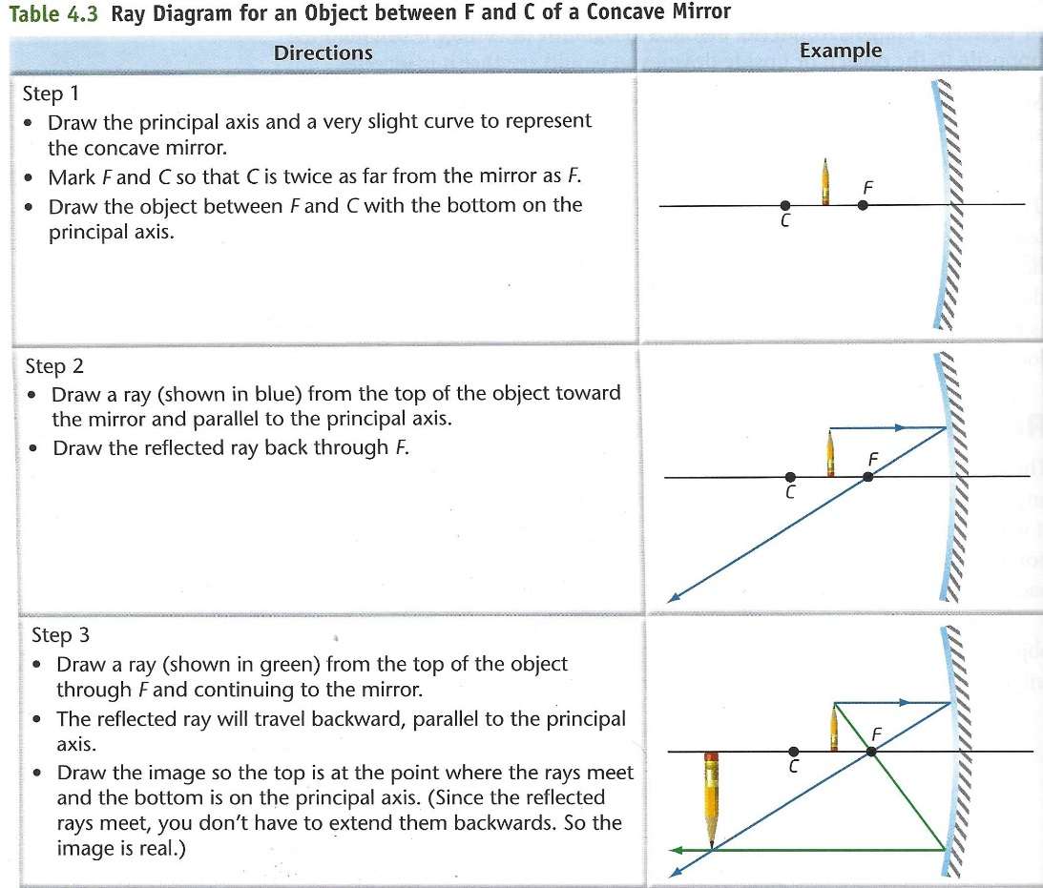

- Following the instructions above, draw the image as it should appear.
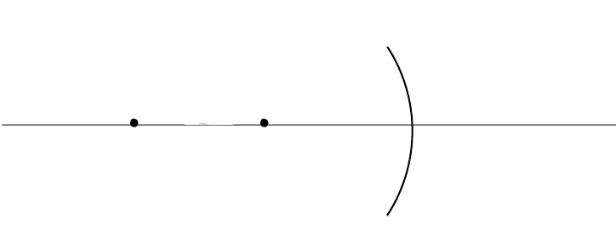

Describe your image:
Is it upright or inverted?
Is it larger or smaller than the object?
Is it closer or further from the mirror?
Is it real or virtual?

